**Bank Management System Structure:**

2 Options will be available:

1. Register - Register page will be displayed and the user needs to enter the data
2. Login - user will login and the creds will be matched with the data in the database

Menu will be displayed:

1. Create bank account
2. Perform Transaction
3. Customer details
4. Transaction details
5. Delete Account
6. Quit

When Option:3 or 4 is selected - Data is fetched from the database.

When Option:1 or 2 or 5 or 6 is selected - Data is inserted into the database and the actions are performed.

#### Order of Execution:



* Create database: bank
* Create user_table table: To store the login creds
* Create customer_details table: To store the customer details (profile info)
* Create transactions table: To store the transactions details (mini statement)
* Create Menu
* Create Mainbank --- **Execute NOW.**

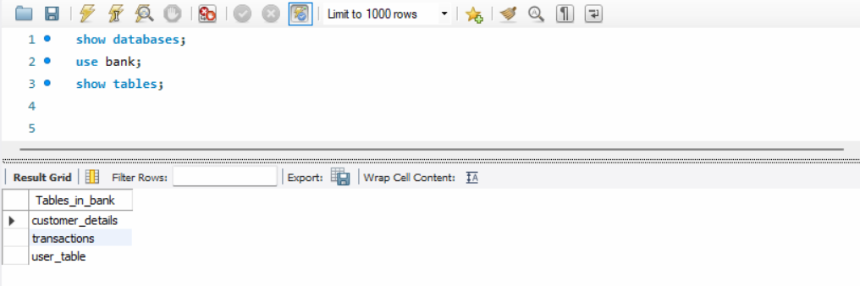

**User Registration > Routing to Menu after registration**

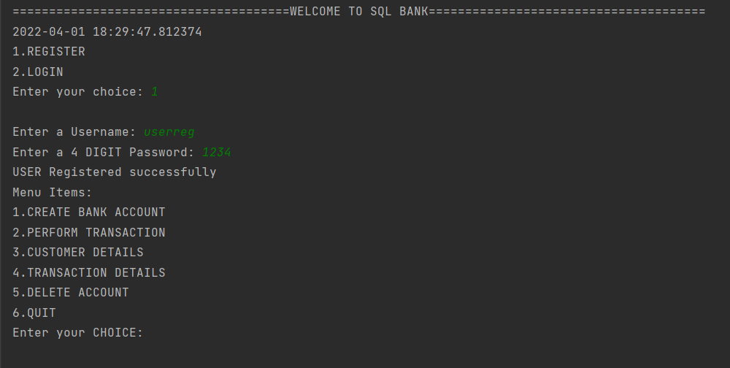

**Login creds stored in user_table:**

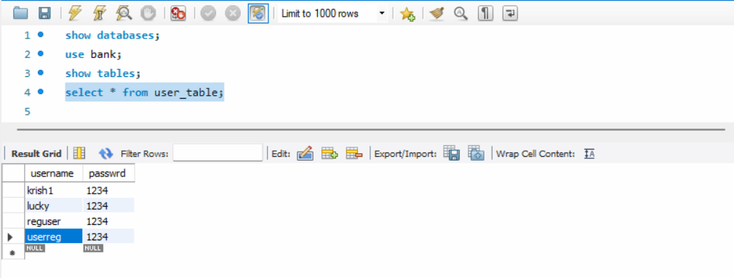

**Login - Invalid > Request for login details again**

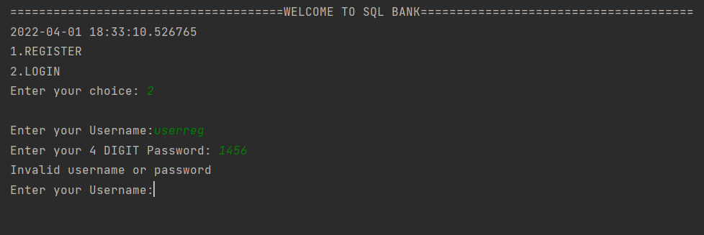

**Login Success > Routing to Menu after login**

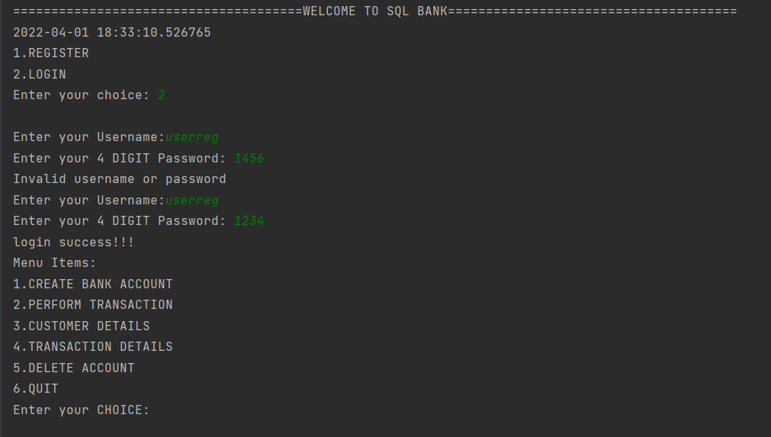

**CREATE BANK ACCOUNT:**

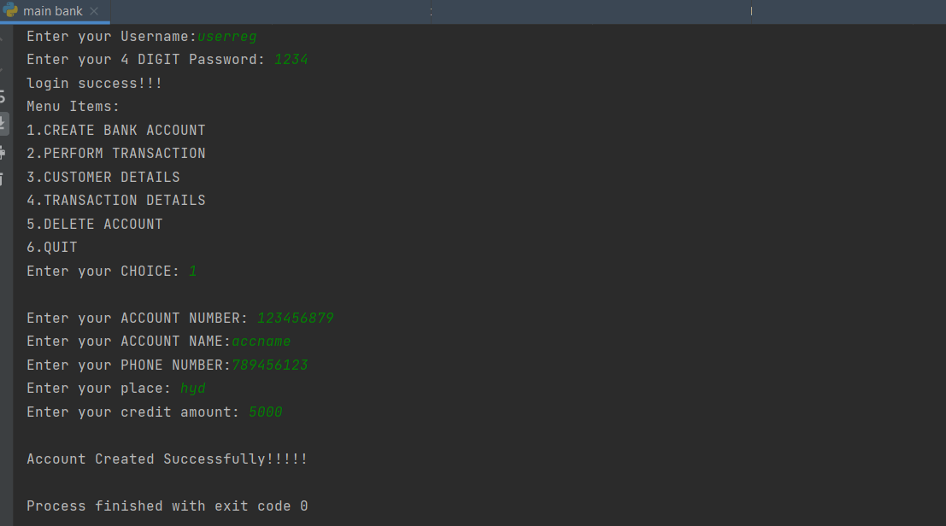

**Account details stored in customer_details table:**

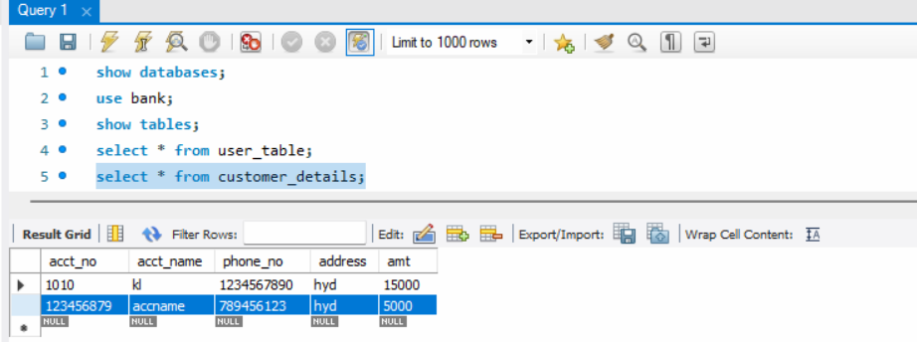

**PERFORM TRANSACTION:**

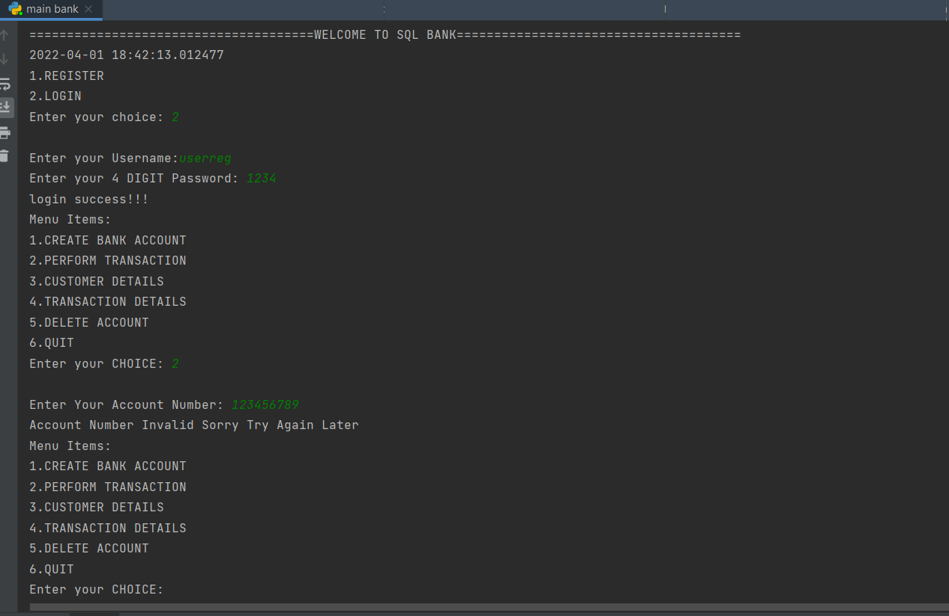

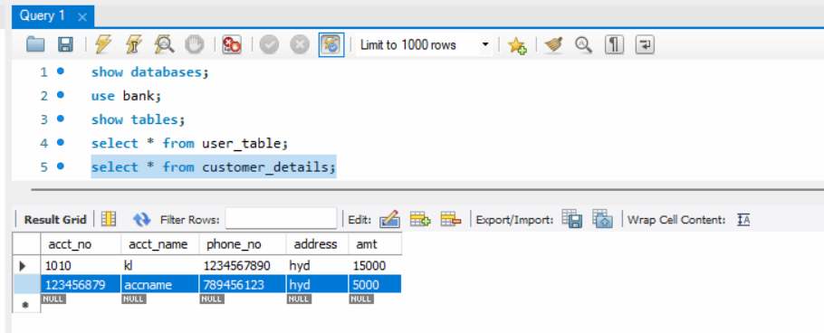

**WITHDRAW AMOUNT:**

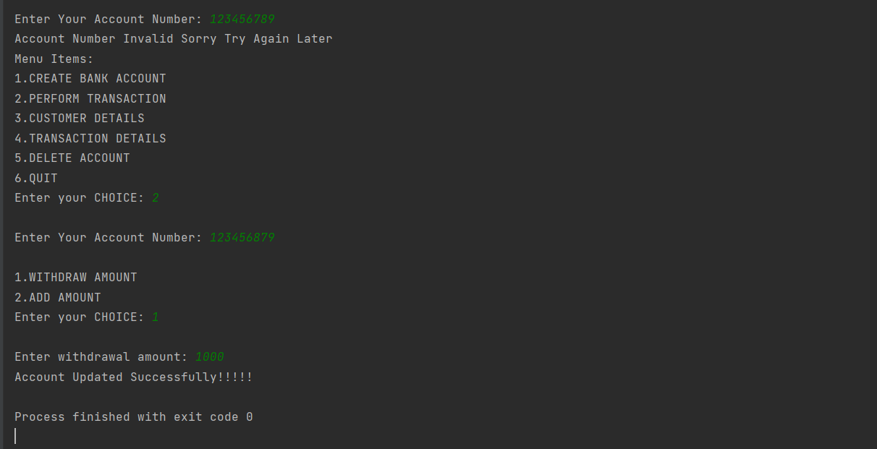

**Amount updated in customer_details table:**

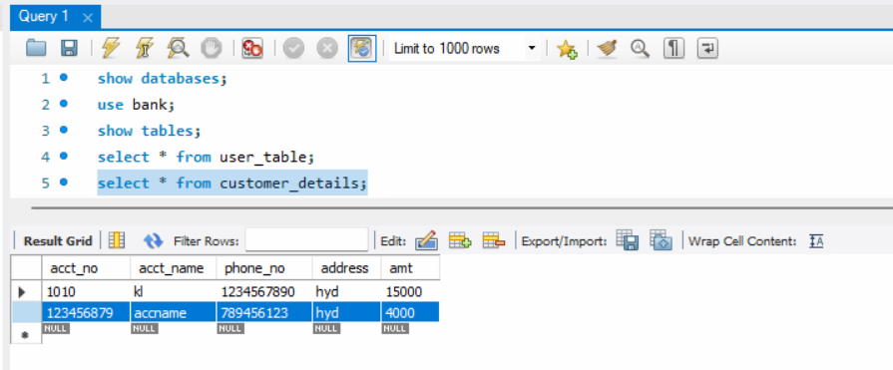

**Transaction captured in transactions table:**

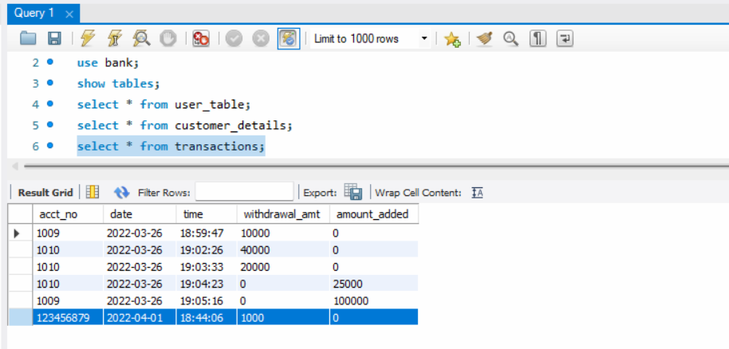

**ADD AMOUNT:**

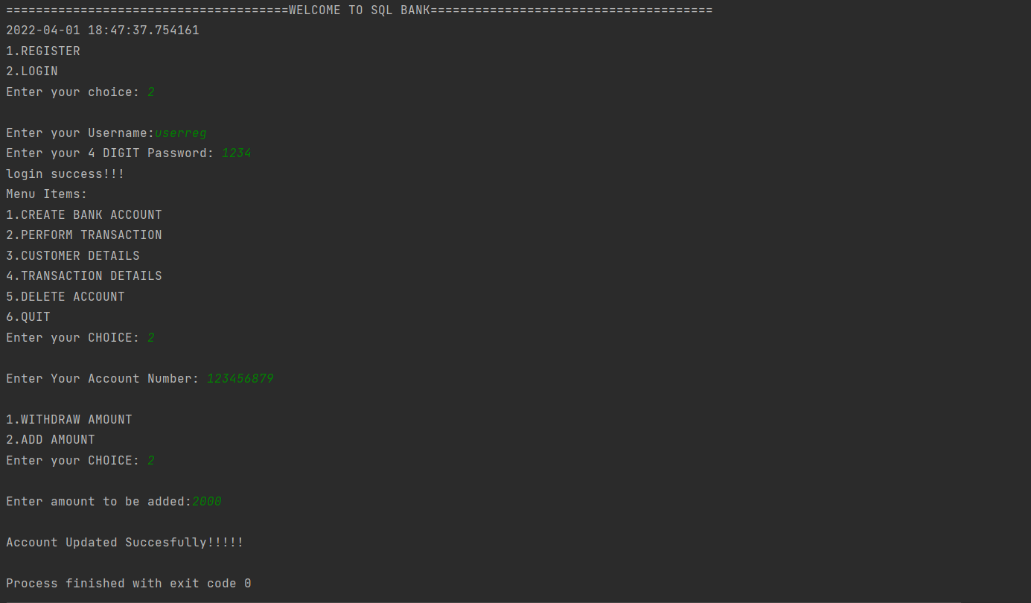

**Amount updated in customer_details table:**

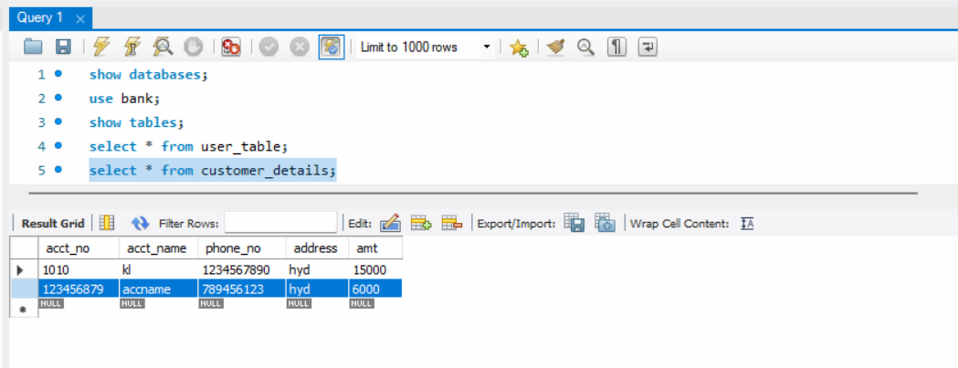

**Transaction captured in transactions table:**

